19162121031

SMIT R PATEL

SEM 5

BDA

PRACTICAL 11

AIM- To understand the working of Basic Hive commands.

Exercise:

You work for the HR department in a Multi-National Company. You notice that Excel is taking a

long time to open the file, hence you are suggested by a Co-worker to use Hive in Hadoop since

you are okay with working in SQL like queries. You need to access some information for your

employees. Do the following:

Tasks:

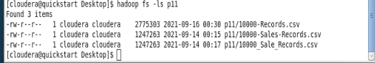

1. Create a table “employee” and move your employee records into it.

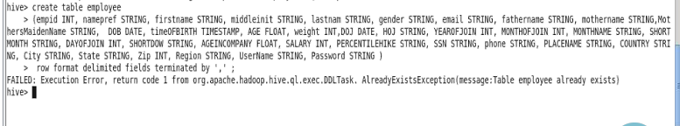



2. Display employee information where salary>25000.

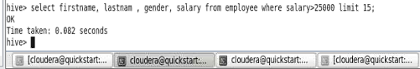

3. Create another table “orders” and move your order data into it.

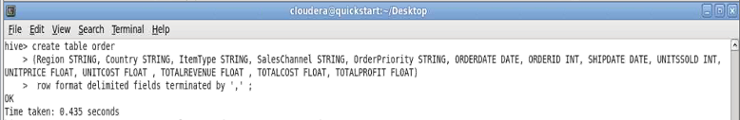

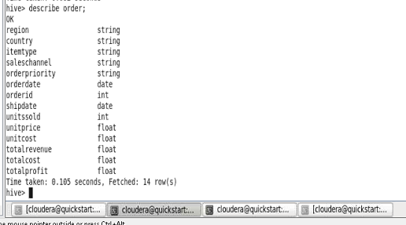

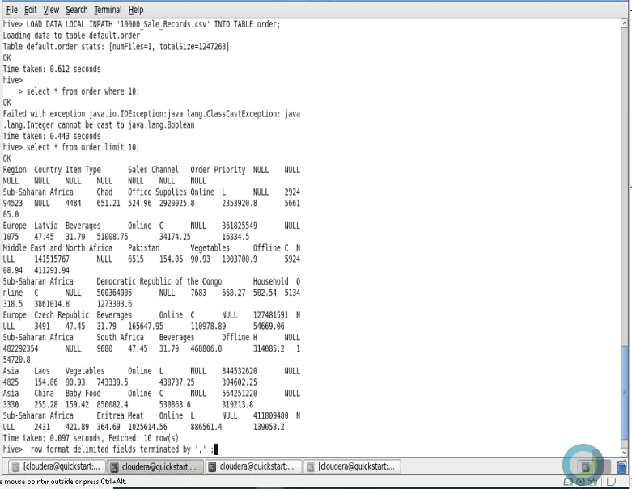

4. Try joining the two tables together.

🡪 We can not join two tables together because

* No column same in both table.
* No find primary key in both table.
* No find unique column in both table.

So , here we can not join two tables together.